My Experience in Creating StudyTimer
When the idea of code literacy was first introduced in our lectures, I was able to understand it on an intellectual level. However, it was not until the completion of the StudyTimer application that I fully immersed myself into the concept of thinking computationally. My application started as an attempt to help with my own problem of not staying focused while studying, but it turned into something much more profound.
What Drove My Need to Create It?
As someone who has always found it difficult to focus on their studies, it seemed ironic that this was precisely the area of knowledge that I was trying to acquire as a student of computational systems—I, of all individuals, could not seem to efficiently allocate resources on how to take best advantage of mine. The lightbulb moment occurred during a particularly distracting study session. The question that occurred was this: What if I created something that catered not to how I was SUPPOSED to study, but how exactly I do?
This aspect of humanity was what acted as the motivation behind my project. I was reminded of the concept of low floors, high ceilings by Resnick et al. (2009) in our readings because I felt the desire to do something introductory, and I could elaborate on this concept with more knowledge of coding. Can you recall how innocent the project proposals sound? It started with a request of a timer that beeps when the study time ends. And how this minor of my requirements would launch me into object-oriented programming, data graphics or user experience principles, had I dreamed.
This directly illustrated Norman's (2013) concept of the 'system image' gap outlining the disconnect between my mental model of how the timer should work and the user's actual understanding, and to bridge this I needed to apply the user-centered design principles.
Where Theory Met Practice
My first concept map was more of a technical specification diagram. All arrows led from Python libraries and functions. However, after discussing it with fellow students in the tutorial sessions, I was forced to consider the human aspect. A classmate asked, "How will you feel when the timer sounds? Will it be an interrupt or relief?" This question completely turned the design on its head.
However, I began looking upon the project not merely as a timer but as an ongoing dialog process from me to the computer. While implementing the design with Tkinter, I first created something that was perfectly intuitive in my own mind but puzzling to every tester that I handed it to. The naming of the push buttons was misleading, the progress bar was not animating nicely, and the notifications seemed more like annoyances than useful functions. I had fallen into the pitfall which Rushkoff (2010) cautions us about in our readings on coding: coding the computer to think like me.
The turning point was achieved after I chose to consider the entire debugging process as a kind of conversation. The messages or expressions of error were no longer messages of error, but messages of how there was still a difference between what was going on in my head versus what was going on in the computer. The moment that the `after()` method was achieved to give a smooth timer update that did not freeze the entire GUI, it was almost like waving a magic wand. This innovation proved the idea of computational materiality as coined by diSessa (2000) because the after method was to introduce a sense of intuitive feel of how code is run as opposed to a syntax rule enumeration.

The Evolution: From Functional to Meaningful
When the simple timer started operating, I started to question the information which was being captured. All the sessions of testing provided information about focus patterns, break patterns and productivity patterns. It was here that the project transformed into something better than a utility.

The Matplotlib implementation of the visualization dashboard was like having a mirror to myself to learn about my learning habits. I learned that I was most effective when working in late morning shifts and I worked better when having slightly more breaks between some subjects. This data-based self-awareness was the same as the principles of Cairo (2012) regarding functional art the visualizations were not merely beautiful but also informative.
The customization tools were an extension of the understanding that in each and every day there was a new need where my research study can be useful. Days would come when I would be able to focus on a long duration of time and then there are days that I would rather have more breaks. The development of the settings window taught me a great deal regarding the optimization of flexibility with common sense.
Course Concepts
Concepts from our coursework kept reappearing in interesting ways throughout this process. The act of employing object-oriented programming techniques for the timer logic became a firsthand lesson in dealing with complexity by encapsulation.
The most pertinent link was discovered in the realization of the replication of exactly what Papert (1980) outlined in regard to constructionist learning. What was happening was more than the creation of a timer. What was occurring was the building of an understanding. Each problem, from sound processing to data saving, was an experience of reconstructing current knowledge. Below is part of the code showing timer creation.
# Event-driven architecture
def update_timer(self):
if self.timer.is_running:
still_running = self.timer.update()

if not still_running:
# Session ended naturally
session_info = self.timer.get_session_info()

# Log completed session
if self.timer.current_session == "work":
duration = self.timer.work_duration // 60
self.session_manager.save_session("focus", duration, completed=True)
else:
break_type = "short_break" if self.timer.current_session == "short_break" else "long_break"
duration = (self.timer.short_break_duration if break_type == "short_break"
else self.timer.long_break_duration) // 60
self.session_manager.save_session(break_type, duration, completed=True)

self.play_sound()
messagebox.showinfo("Session Complete!",
f"{session_info['name']} finished!\n"
f"Ready for {session_info['next_session']}?")

self.update_display()
self.root.after(1000, self.update_timer) # Update every second

The peer feedback sessions were invaluable. For instance, when one of the testers asked for the inclusion of session notes, I was averse to it—to me, it seemed unnecessary. However, later on, our discussion on extensible design helped me realize that often the best designs tend to extend beyond their intended use. Learning how to incorporate this feature taught me more than a tutorial ever could.
Reflections and Realizations
Turning backwards through the project log, it seems that I can track the development of my thoughts. "How do I create a countdown timer? Why doesn't this button function?" The earlier log postings center upon technical issues. The later ones revolve more around more intellectual issues. "How can a smoother transition from one session to another be achieved? " "What is the most effective methodology for progress indication which doesn’t result in anxiety? " This evolution from technical to conceptual questions reflects Resnick et al.'s (2009) 'high ceilings' concept thinking more about the user experience and emotional impact rather than just functional requirements.
This indicates that I have developed a higher level of code literacy. Although I began to view coding as typing in the correct syntax, it is becoming more and more an act of communication. This may be with the computer with the users of the code in future or with me. Following rules as a form of coding has ceased being a matter of rule following and has become a part of coding culture.
The two concept maps which I have created narrate themselves. The initial concept map is more technical and was focused on dependencies. My second concept map was more holistic and demonstrated the interaction of the user emotions, learning context, and technical systems. This is metaphorical to how I have learned to value human context of computation systems.
Moving Forward: Code Literacy
The project has modified my relationship with technology. In place of a completed product, an application, what I would have thought of is now a conversation. Something that I might have previously found as a cause of anxiety and a subject of programming is now astounding me with the wonder of what will be found. The StudyTimer works- I receive the appropriate beeps, it is also able to follow my patterns of usage, and it displays gorgeous graphs of data. What is more significant, the course of its creation has opened my eyes to the world of computation in a fresh perspective altogether. I will be looking not only at the performance of different applications, but the way these applications would be organized, how they would react to constraints. The StudyTimer currently sits on my computer desk, and is counting down time to each study period, but it is the skills of computational thinking that I have acquired in its creation that is actually of use to me.
Peer Reviews
The peer reviews praised the code for its inventiveness, interactivity, and smooth fusion of music and coding while offering helpful suggestions. For easier navigation and customization, reviewers recommended creating a more user-friendly interface, adding clearer instructions and comments, and improving the documentation.
References
Cairo, A. (2012). *The functional art: An introduction to information graphics and visualization*. New Riders.
Papert, S. (1980). *Mindstorms: Children, computers, and powerful ideas*. Basic Books.
Resnick, M., Maloney, J., Monroy-Hernández, A., Rusk, N., Eastmond, E., Brennan, K., Millner, A., Rosenbaum, E., Silver, J., Silverman, B., & Kafai, Y. (2009). Scratch: Programming for all. *Communications of the ACM*, 52(11), 60–67. https://doi.org/10.1145/1592761.1592779
Rushkoff, D. (2010). *Program or be programmed: Ten commands for a digital age*. OR Books.
Wing, J. M. (2006). Computational thinking. *Communications of the ACM*, 49(3), 33–35. https://doi.org/10.1145/1118178.1118215
Appendices
- Review
Review 1
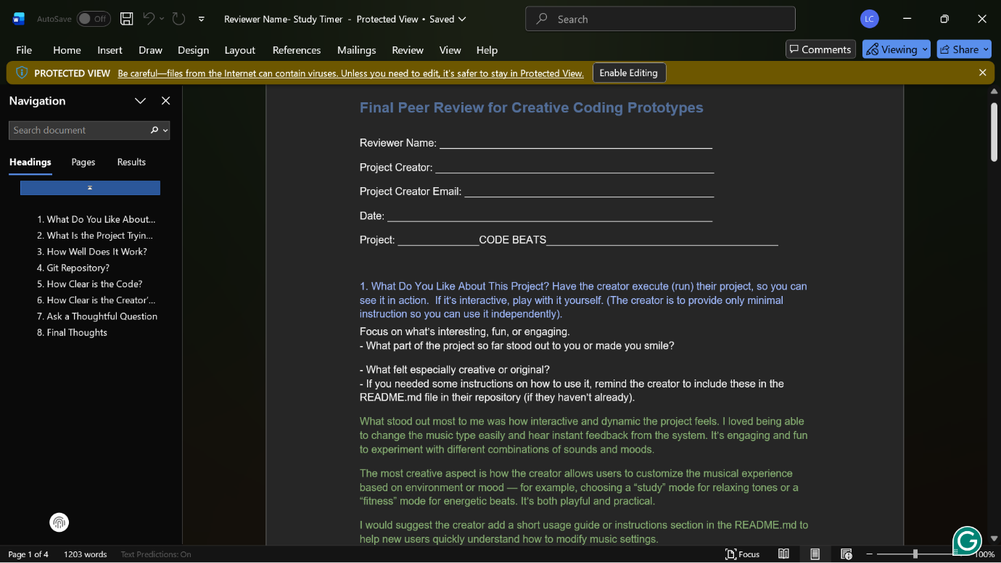
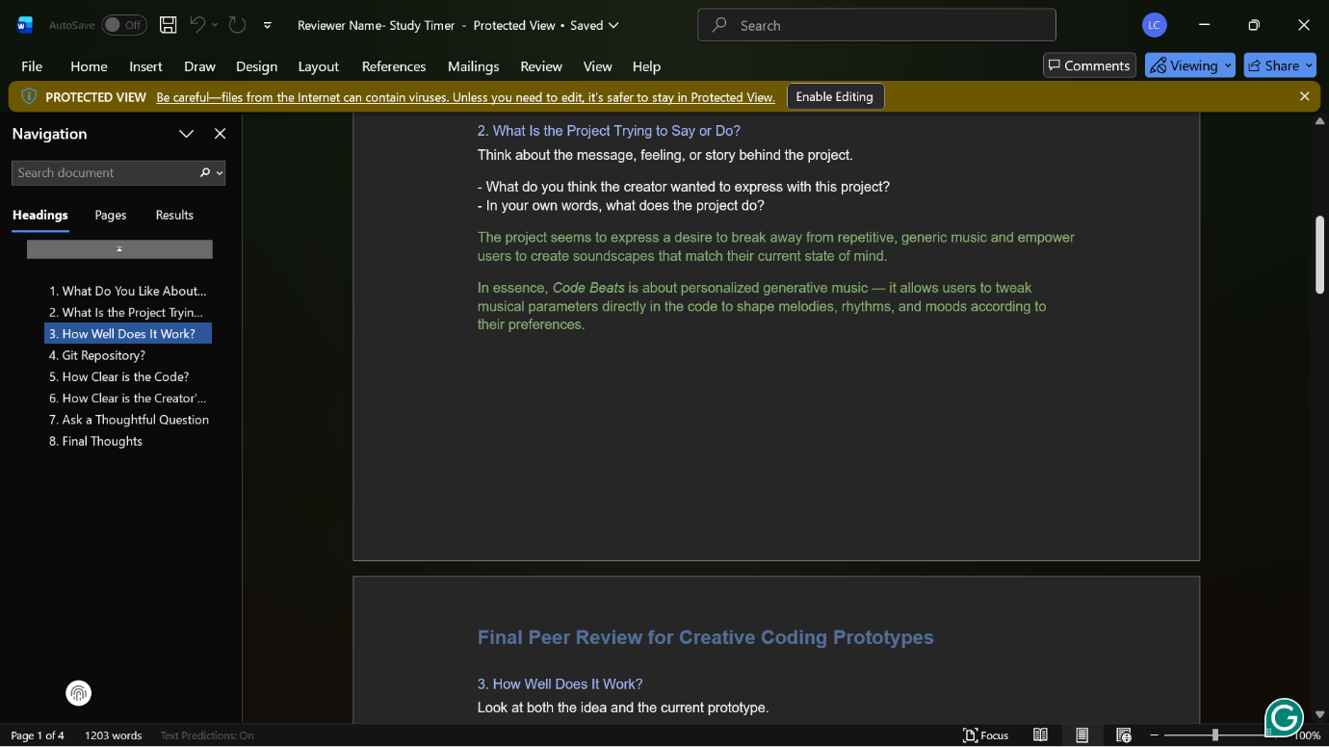
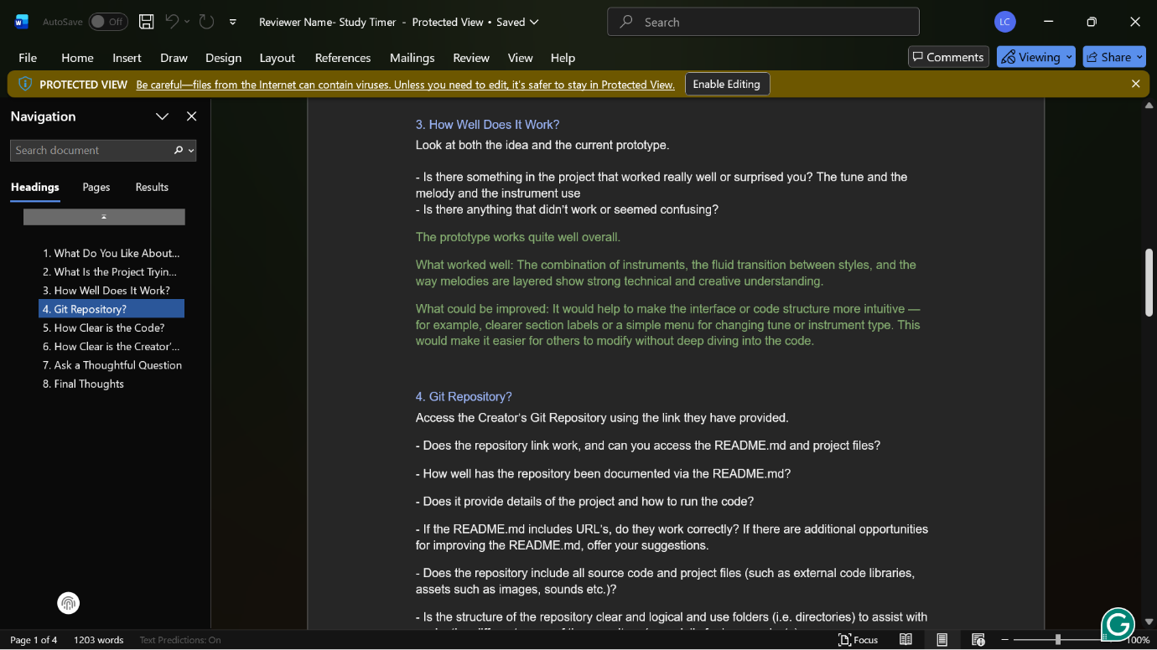
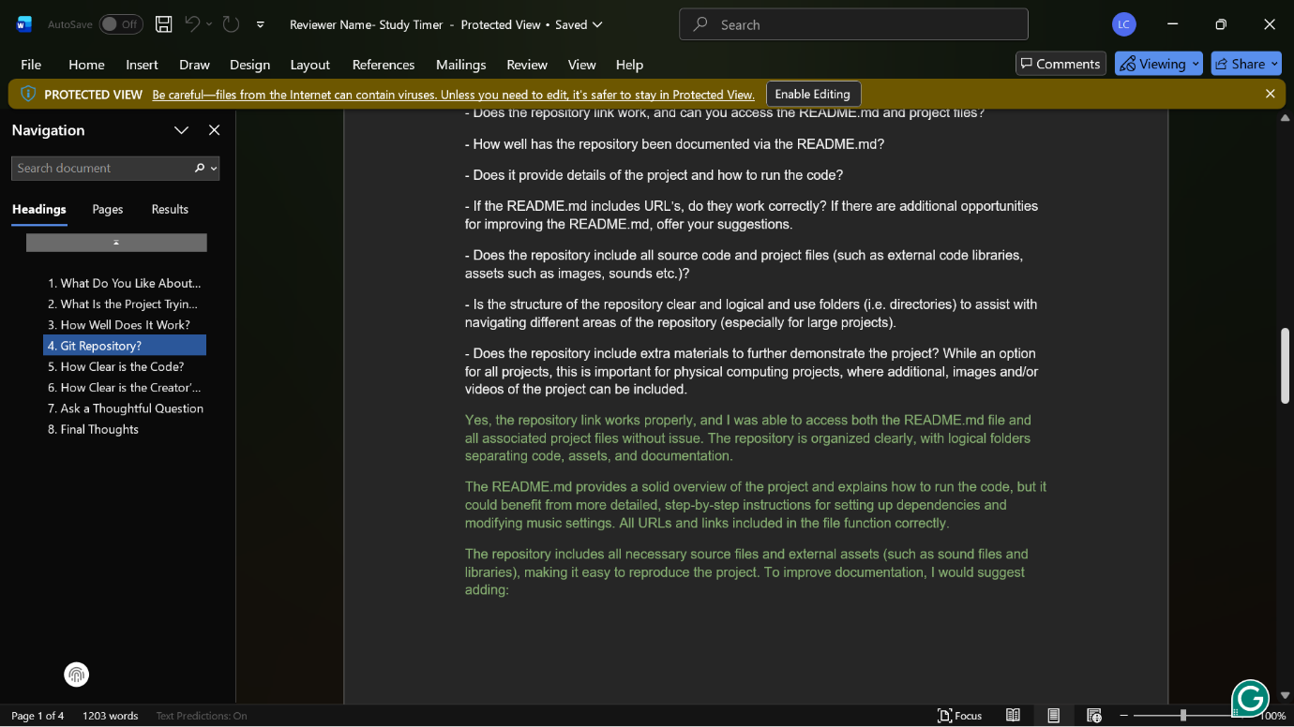
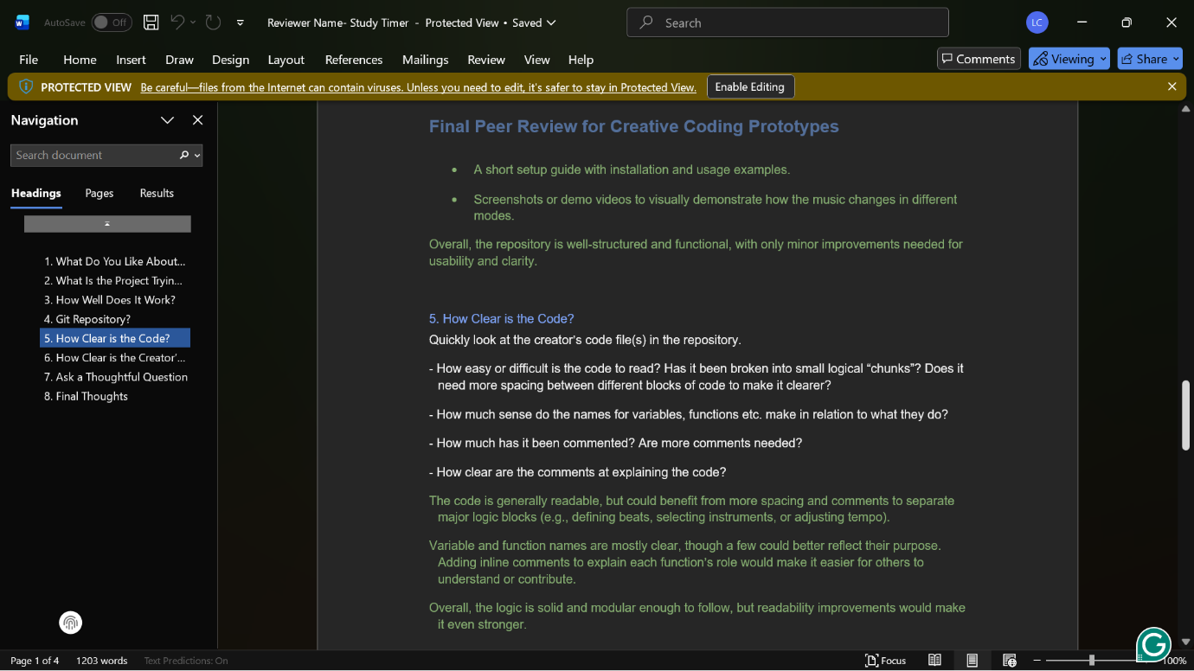
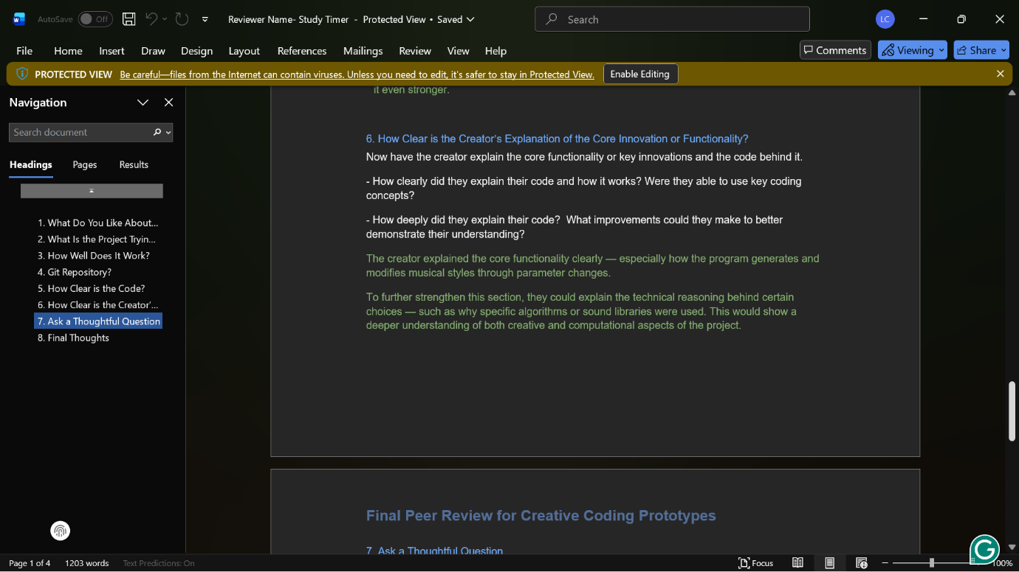
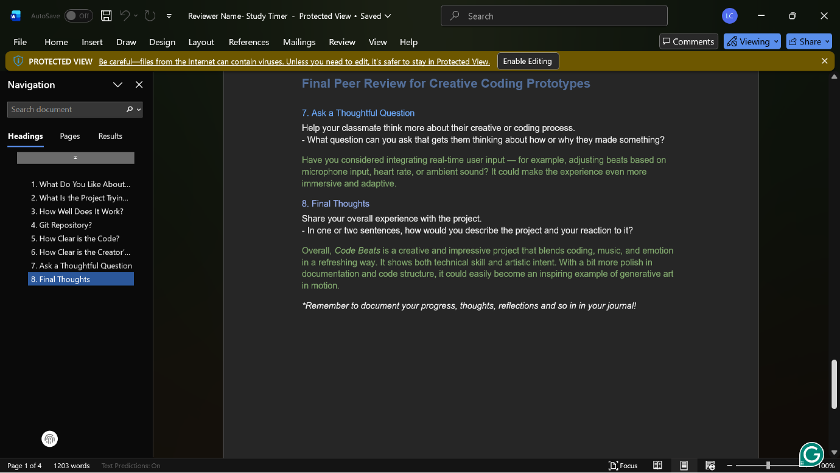

Review 2
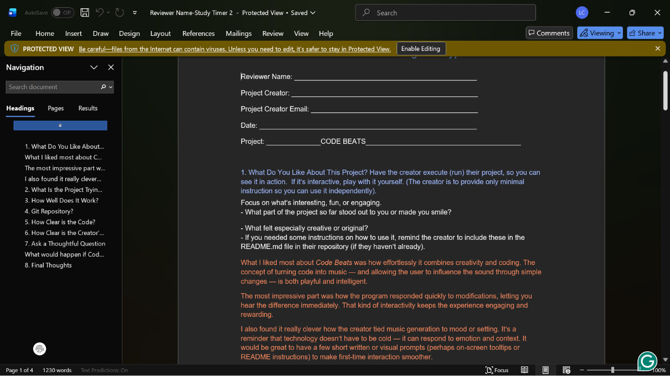
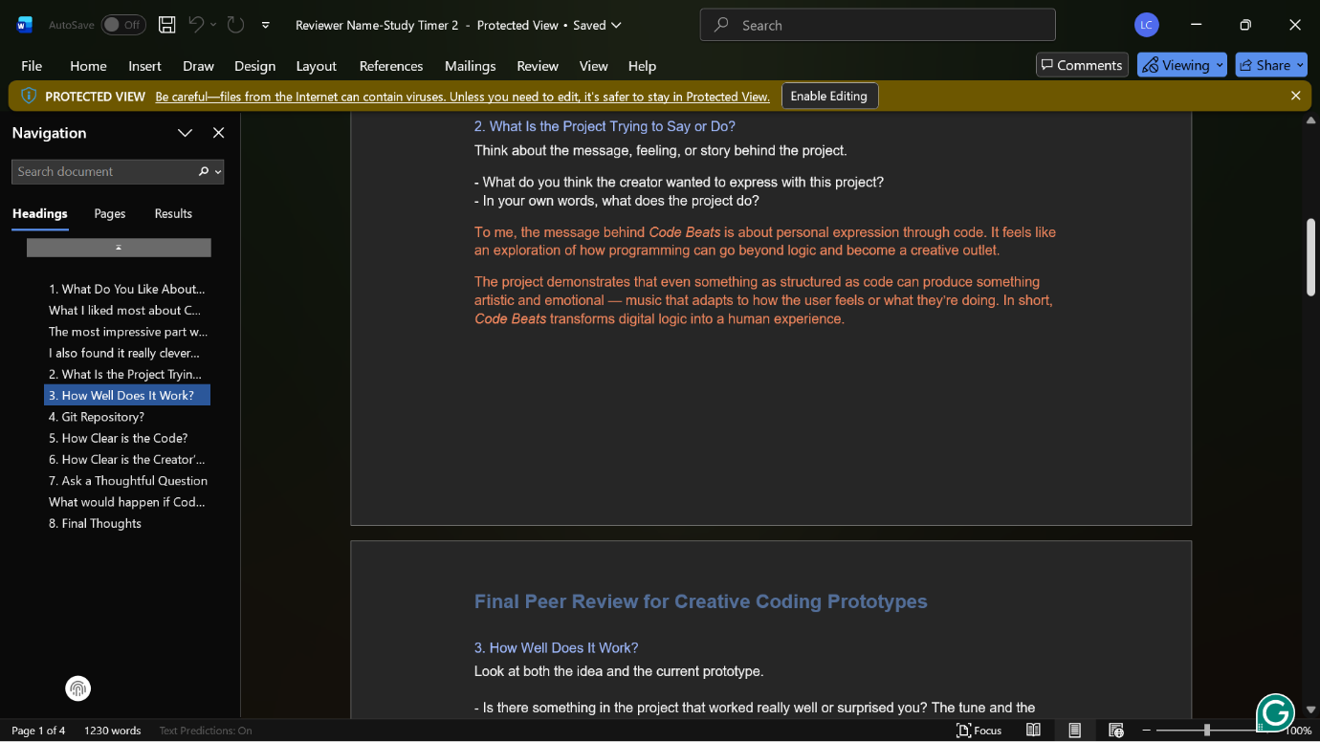
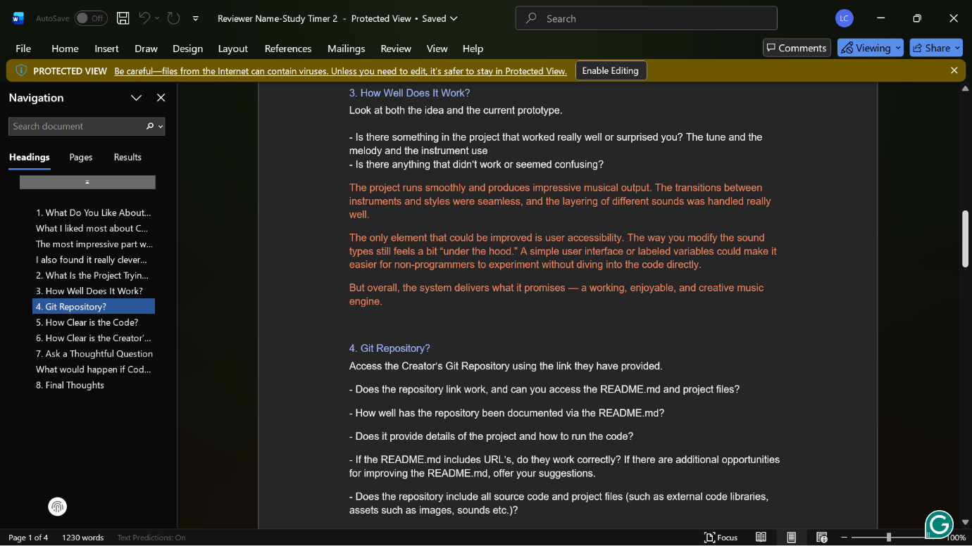
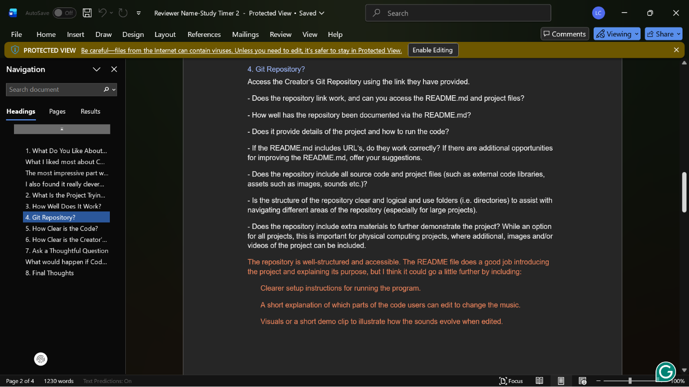
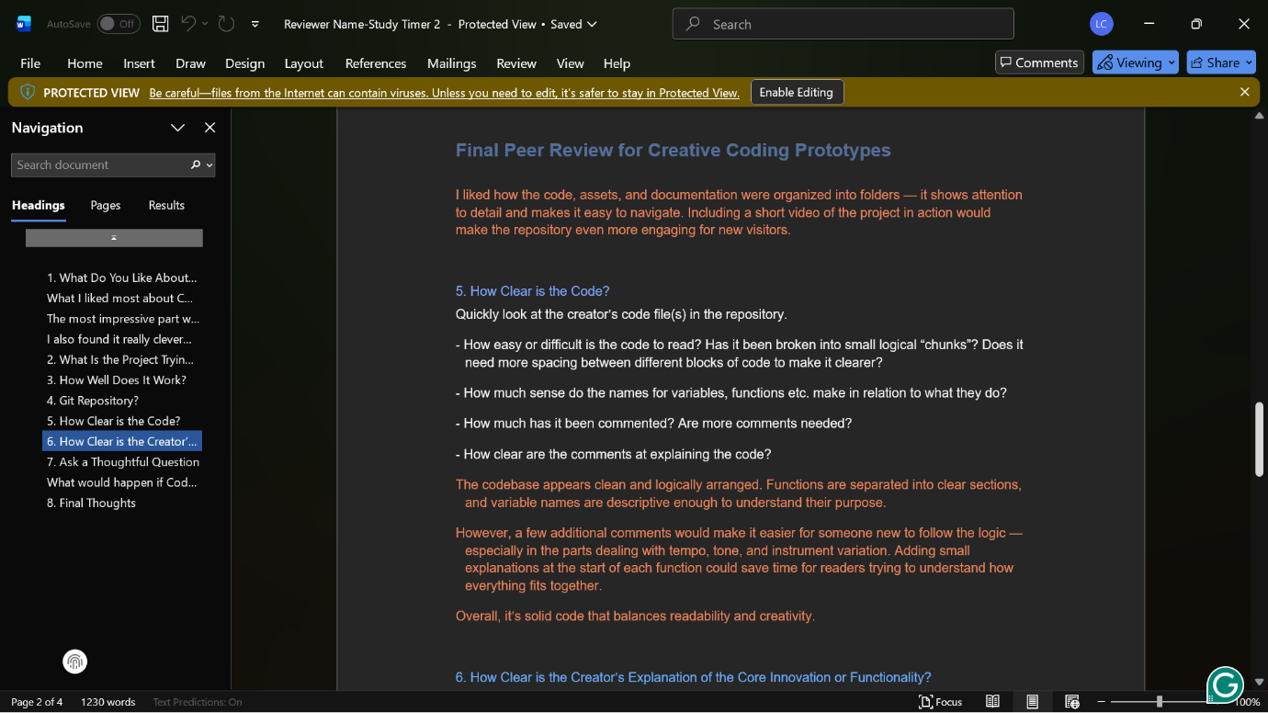
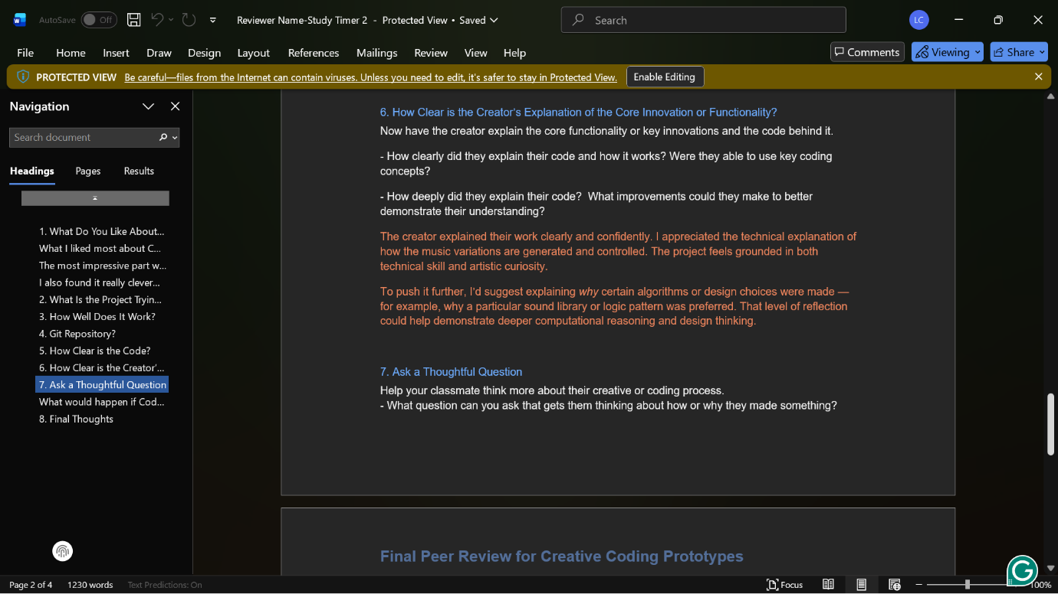
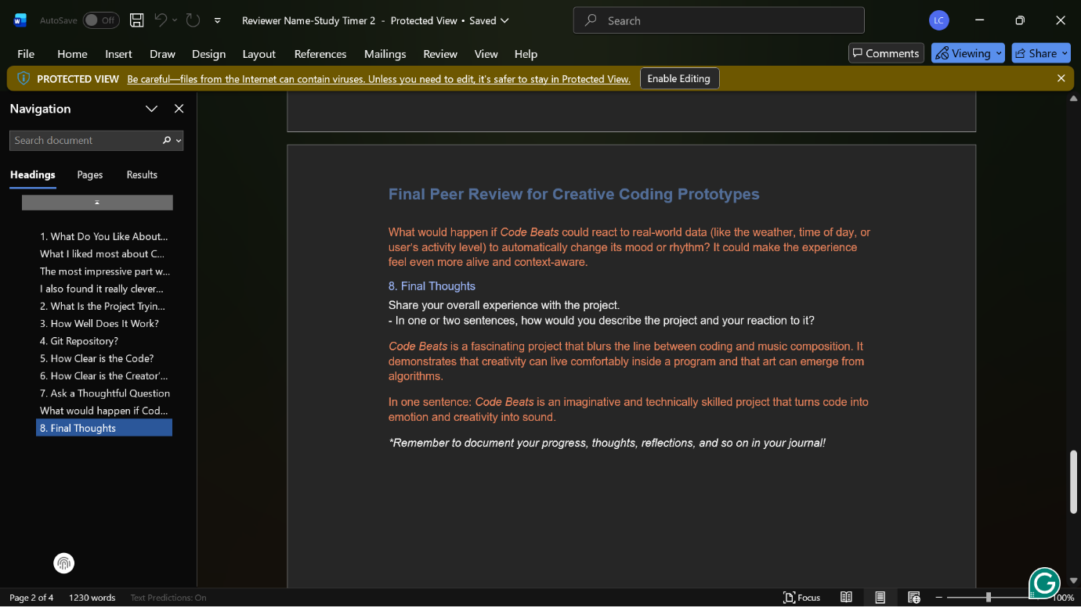
- Journal entry
When I began to create the StudyTimer, I envisioned it as a mere project to assist me in focusing on studying. I used to get distracted a lot, and I needed something that would help me maintain some form of consistency. Initially, it was really a simple concept, a timer that counts down and beeps in case the time is up. However, as I started creating it, I noticed that I was not only learning how to write a program and have it run, but also how to think, ponder, and write using code.
During the initial phases, I was entirely focused on the technical perspective. I desired the smooth operation of the timer, proper functioning of the buttons, and an appealing interface. I wasted hours debugging the reasons why the progress bar was not progressing or the reasons why the labels were not displaying correctly. Each tiny bug was a defeat, and, with time, I began to see them differently. I started to view error messages as a way of guidance instead of failure. Each bug taught me something about the computer misunderstanding my logic, and each fix provided me with confidence. By the time I was able to bring the after method under a smoothly and fluidly running procedure, it was like a breakthrough in my head- it was as though I had mastered the language of the computer a syllable more.
One of the most important aspects of the project was peer feedback that was provided in the project. During one of the review sessions, a classmate of mine came up with an idea that I needed to create a place in which the user could leave short notes after each study session. I, initially, denied the idea because I did not feel the need. I had only an interest in keeping time, and not thoughts. But, thinking more about it, I had seen the worth there could be in such a triviality. It helped the timer to go beyond being a tool- it became a friend, one to be thought of. The inclusion of the notes section was a more human and interactive way to make the app, and the process made me realize how crucial collaboration is in the design. Peer review has taught me that feedback is not to be viewed as a critique, but as a chance to build upon an original idea and improve it.
I continued to optimize the project, and as I did so, I realized just how much my thinking had changed. My previous entries in the project log were strictly technical, such as how to fix, position, or attach some features. My thoughts later became conceptual. I started posing such questions: What does the timer do to make a user feel? Is it inspiring or pressurizing? What can I do to make the transitions between sessions seem natural? The change made it clear to me that I was no longer writing code; I was creating an experience.
StudyTimer was no longer a productivity tool by the time the project was completed. The graphics of my data of interest made me realize some trends in studying and working hours. When I saw those graphs, I felt as though I had been looking at a mirror that was showing me my learning patterns. The whole process of coding, debugging, testing, and feedback allowed me to develop in a better way than I previously thought. I would now consider programming not only as a technical process, but as a creative and reflective one. The StudyTimer is still helpful in my studying, yet, more importantly, it symbolizes the way I have acquired greater knowledge about patience, design, and collaboration in the process of creating it.

- Code snippets
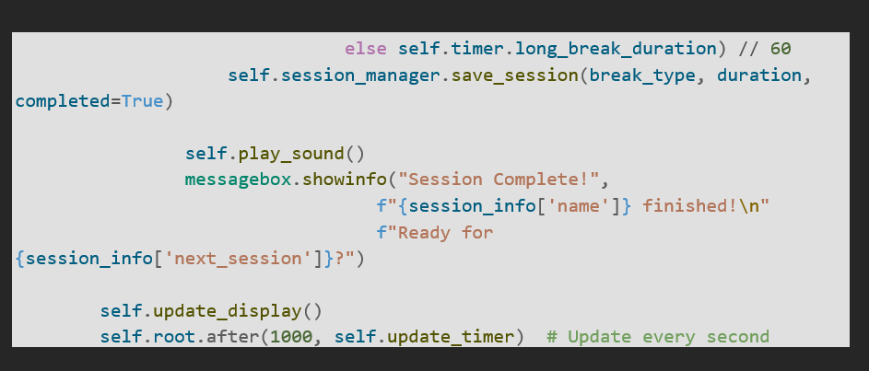
Here, the break type (short or long) is verified and completed session is saved by the save session code. Then it gives a sound and displays a pop-up message that the user is over with the session and that he/she is going to start another. Lastly, it will refresh the display and start self.root.after(1000, self.update_timer) to update the timer every 1000ms or one second of time so that the countdown would run flawlessly in real time.

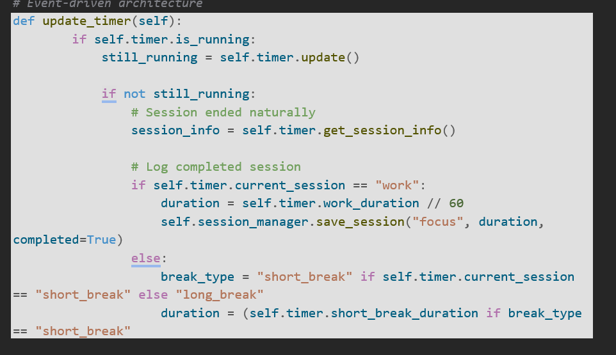
This code specifies the update timer function, which controls the running of the timer and which keeps a record of the completed sessions. It initially verifies whether the timer is still running otherwise, there is an indication that a session has been terminated. The code then recalls the information on the completed session and records it - whether it is a focus session or a break (short or long) and the duration. In essence, it maintains the timer on track and logs every work or break session done automatically.

